ASSIGNMENT 1
Simlin Saha
2026-01-22

PREDICTIVE ANALYTICS

Problem Set 1: An Introduction
Download “Boston” housing data from MASS library in R. Complete the task given below and submit the report using R markdown. You need to copy each question as well.
library(MASS)
data(Boston)
1. Report the “class” of the data set. How many rows and columns are in this data set? What do the rows and columns represent?
library(MASS)
class(Boston)
## [1] "data.frame"
dim(Boston)
## [1] 506 14
It contains 506 rows and 14 columns.
Each row represents a suburb (or census tract) of Boston.
Each column represents a housing, demographic, environmental, or socio-economic variable measured for that suburb.
2. Create a smaller data set with the variables median value of owner-occupied homes, per capita crime rate, nitrogen oxides concentration, proportion of blacks and percentage of lower status of the population. Choosing median value of owner occupied homes as the response and the rest as the pre- dictors, make scatter plots of the response versus each predictor. Present the scatter plots in different panels of the same graph. Comment on your findings.
boston_1 <- Boston[, c("medv", "crim", "nox", "black", "lstat")]
head(boston_1)
## medv crim nox black lstat
## 1 24.0 0.00632 0.538 396.90 4.98
## 2 21.6 0.02731 0.469 396.90 9.14
## 3 34.7 0.02729 0.469 392.83 4.03
## 4 33.4 0.03237 0.458 394.63 2.94
## 5 36.2 0.06905 0.458 396.90 5.33
## 6 28.7 0.02985 0.458 394.12 5.21
Scatter Plot
par(mfrow = c(2,2))
plot(boston_1$crim, boston_1$medv, xlab="Crime Rate", ylab="Median Value", main="MEDV vs CRIM")
plot(boston_1$nox, boston_1$medv, xlab="NOX", ylab="Median Value", main="MEDV vs NOX")
plot(boston_1$black, boston_1$medv, xlab="Black", ylab="Median Value", main="MEDV vs BLACK")
plot(boston_1$lstat, boston_1$medv, xlab="LSTAT", ylab="Median Value", main="MEDV vs LSTAT")
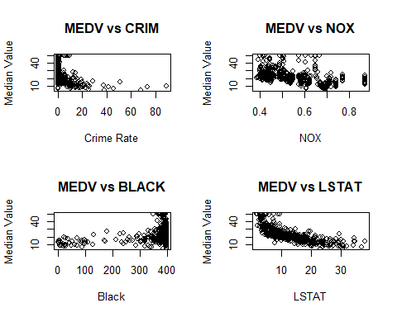 Findings
Crime rate (CRIM) shows a negative relationship with median house value — suburbs with higher crime rates tend to have lower housing prices.
Nitrogen oxide concentration (NOX) is negatively related to median value, indicating that higher pollution levels are associated with lower house prices.
Proportion of Black residents (BLACK) shows a weak positive association with median house value, though the relationship is not very strong.
Percentage of lower status population (LSTAT) has a strong negative relationship with median house value, making it one of the most influential predictors.
3. Which suburb of Boston has lowest median value of owner-occupied homes? What are the values of the other predictors mentioned in (2), for that suburb. How do these values compare to the overall ranges for those pre- dictors? Comment on your findings. Hint: Mention which percentile these values belong to.
min_medv_index <- which.min(Boston$medv)
Boston[min_medv_index, c("medv", "crim", "nox", "black", "lstat")]
## medv crim nox black lstat
## 399 5 38.3518 0.693 396.9 30.59
# Percentiles of predictors for that suburb
suburb_values <- Boston[min_medv_index, c("crim", "nox", "black", "lstat")]
percentiles <- sapply(
c("crim", "nox", "black", "lstat"),
function(var) ecdf(Boston[[var]])(suburb_values[[var]])
)
percentiles
## crim nox black lstat
## 0.9881423 0.8577075 1.0000000 0.9782609
Comments
The suburb with the lowest median house value has:
Crime rate in the upper percentile of the dataset.
LSTAT also in the upper percentile, indicating a high proportion of lower-status population.
NOX concentration is relatively high compared to most suburbs.
These predictors lie in unfavorable ranges, which strongly explains the extremely low median housing value.
This suburb represents a combination of high crime, high pollution, and socioeconomic disadvantage, leading to depressed housing prices.
4. Does any suburb of Boston stand out for having notably high crime rates, tax rates, or pupil–teacher ratios? Hint: Use a boxplot to detect any outliers. If so, identify the suburbs that show the outlier values.
par(mfrow = c(1, 3))
boxplot(Boston$crim, main = "Crime Rate", ylab = "CRIM")
boxplot(Boston$tax, main = "Tax Rate", ylab = "TAX")
boxplot(Boston$ptratio, main = "Pupil–Teacher Ratio", ylab = "PTRATIO")
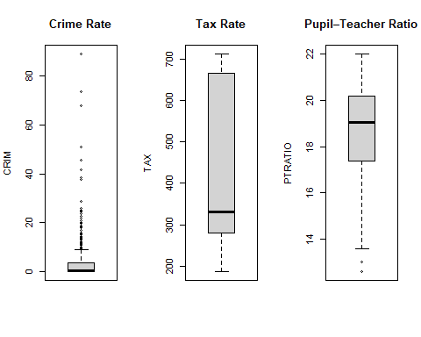
# Identify suburbs with outliers
out_crim <- which(Boston$crim %in% boxplot.stats(Boston$crim)$out)
out_tax <- which(Boston$tax %in% boxplot.stats(Boston$tax)$out)
out_ptratio <- which(Boston$ptratio %in% boxplot.stats(Boston$ptratio)$out)
out_crim
## [1] 368 372 374 375 376 377 378 379 380 381 382 383 385 386 387 388 389 393 395
## [20] 399 400 401 402 403 404 405 406 407 408 410 411 412 413 414 415 416 417 418
## [39] 419 420 421 423 426 427 428 430 432 435 436 437 438 439 440 441 442 444 445
## [58] 446 448 449 455 469 470 478 479 480
out_tax
## integer(0)
out_ptratio
## [1] 197 198 199 258 259 260 261 262 263 264 265 266 267 268 269
Comments
Several suburbs exhibit extreme outliers in crime rates, far exceeding the majority of observations.
Tax rates also show notable outliers, indicating a few towns with exceptionally high property taxes.
Pupil–teacher ratios contain fewer outliers but still highlight some suburbs with unusually strained educational resources.
These outliers may exert strong influence on regression and predictive models, and robust methods or transformations may be required.

